**DESIGN DOCUMENT**

**E-PROJECT**

**PASCAL IMITATION**

PASCAL IMITATION

|  |  |  |
| --- | --- | --- |
| **Supervisor.** | **Miss Qurat Ul Ain** | |
| **Batch.** | **2406E1** | |
| **Group.** | **A** | |
| **Serial No.** | **Enrollment Number** | **Student Name** |
| 1. |  |  |
| 2. |  |  |
| 3. |  |  |
| 4. |  |  |

**ACKNOWLEDGEMENT**

Before anything, I would like to thanks my beloved Miss Quratulain Haider who helped us a lot in reviewing this project within the limited time frame.

Secondly, we would also like to thank the eProject team at Aptech Head Office, who gave us the golden opportunity to do this wonderful project about Pascal Imitation Jewellery

Thirdly, we also thank the eProject team, some of the benefits are as under: Re-enforcement of skills happens in the experiential learning process. ∙ A mentor, ensuring that we do not get drifted, constantly guides us. ∙ It gives us a lot of confidence to face an interview as we have worked on a project. We can explain virtually everything on the subject we have lead it

***SYNOPSIS***

Pascal Imitation is a sophisticated online destination offering a diverse collection of jewelry that merges elegance with variety. Featuring brands like Velvet Elegance, Velvet Vault, and Velvet Sparkle, Pascal Imitation provides jewelry enthusiasts with an exquisite selection of pieces. From luxurious, precious stones to semi-precious gems, the collection spans both original and high-quality artificial designs, catering to all tastes and occasions. Whether you seek timeless classics or trendy statement pieces, Pascal Imitation delivers style, sophistication, and unparalleled beauty for every jewelry lover.

***IMPORTANCE OF OUR JEWELRY***

The importance of **Pascal Imitation** lies in its dedication to offering high-quality, versatile jewelry that meets the diverse needs of its customers. Unlike traditional jewelry retailers, Pascal Imitation combines the allure of both original and beautifully crafted imitation pieces, making elegance accessible to a wide range of customers. Featuring unique brands like **Velvet Elegance**, **Velvet Vault**, and **Velvet Sparkle**, the website is a one-stop shop for everything from precious, heirloom-worthy pieces to trendy, budget-friendly accessories. Pascal Imitation empowers customers to express their style confidently, whether through luxury gemstones or stylish artificial jewelry. This accessibility and commitment to quality make Pascal Imitation an essential destination for jewelry lovers seeking both beauty and value.

***CUSTOMER REQUIREMENT***

***SPECIFICATION (CRS)***

The customer requirements for **Pascal Imitation** can be outlined as follows:

1. **Wide Range of Options**: Customers are looking for a variety of jewelry types, including precious, semi-precious, original, and artificial pieces, to match different budgets and preferences.
2. **Quality and Craftsmanship**: Both the original and imitation jewelry pieces should meet high standards of quality and craftsmanship, ensuring durability and elegance in each design.
3. **Brand Diversity**: With brands like **Velvet Elegance**, **Velvet Vault**, and **Velvet Sparkle**, customers expect distinct styles from each, allowing them to choose pieces that align with their personal taste or occasion needs.
4. **Affordability and Accessibility**: The site should offer a balance of affordable options alongside luxury pieces to cater to a broad audience, making elegant jewelry accessible without compromising on quality.
5. **Detailed Product Information**: Clear descriptions, high-quality images, and details on materials used, size, and care instructions are essential for customers to make informed purchasing decisions.
6. **Ease of Navigation**: An intuitive website layout that organizes jewelry by type, collection, or brand will help customers quickly find what they’re looking for.
7. **Secure and Easy Checkout**: Customers require a reliable, secure, and user-friendly checkout process, with multiple payment options and secure data handling.
8. **After-Sales Support**: Strong customer service for inquiries, returns, and exchanges to ensure a smooth shopping experience and build customer trust.

Meeting these requirements will ensure that **Pascal Imitation** not only satisfies but exceeds customer expectations, making it a trusted destination for jewelry shopping.

***SCOPE OF THE WORK (IN BRIEF)***

The website is to be developed for the Windows Platform using HTML5,    JavaScript and bootstrap jQuery. The site should work well in all leading browsers including Chrome, Firefox etc. Our welcome page icon is re-directed to the main web page Ever essential content direct to relative content.

***Screenshots***

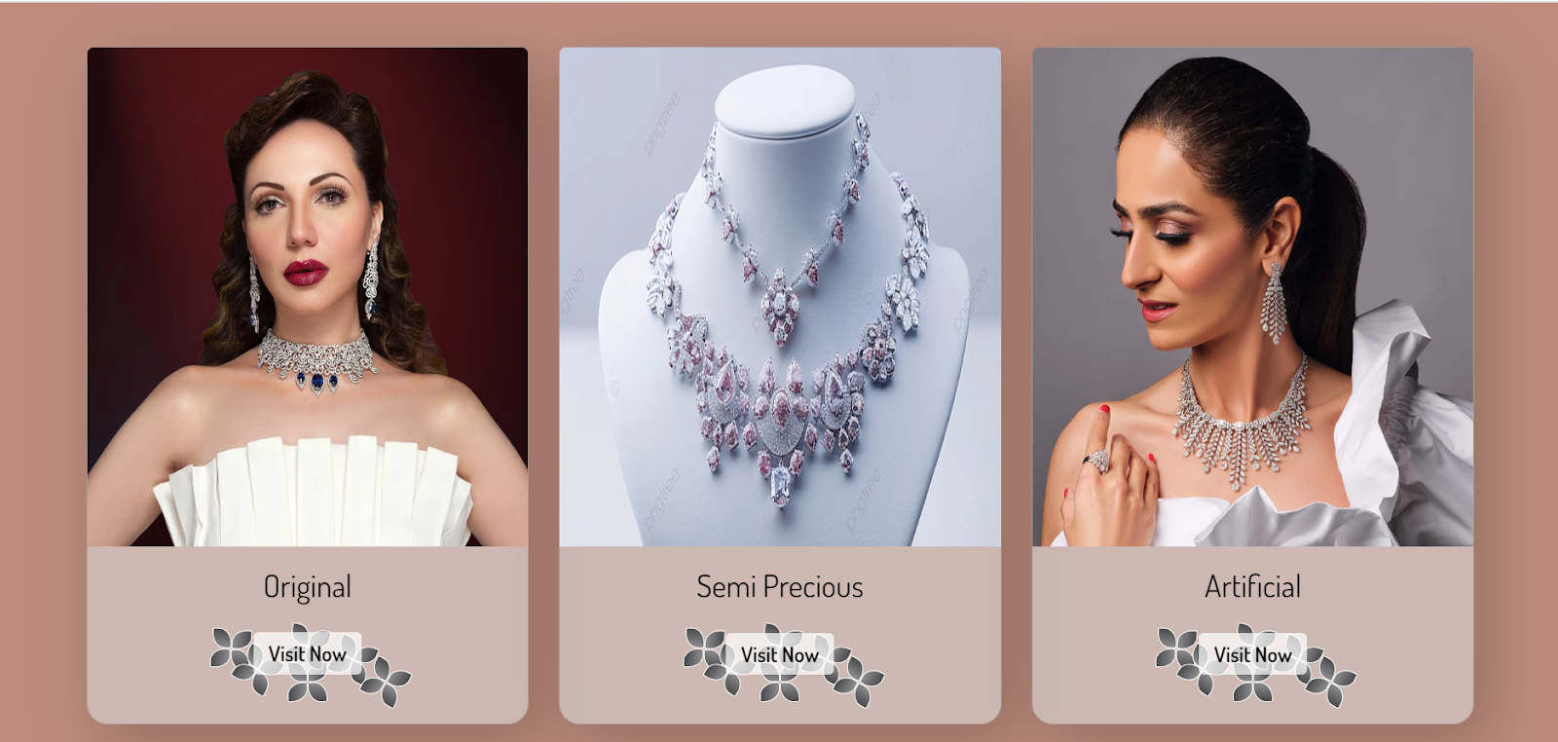

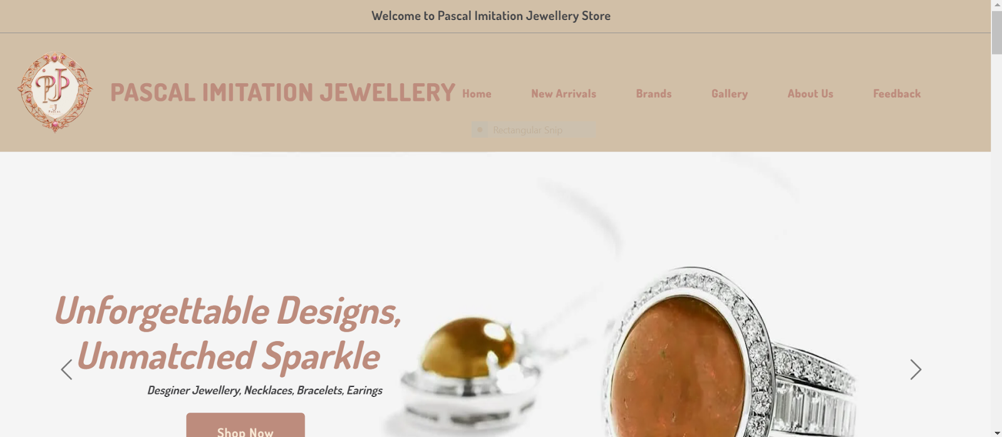

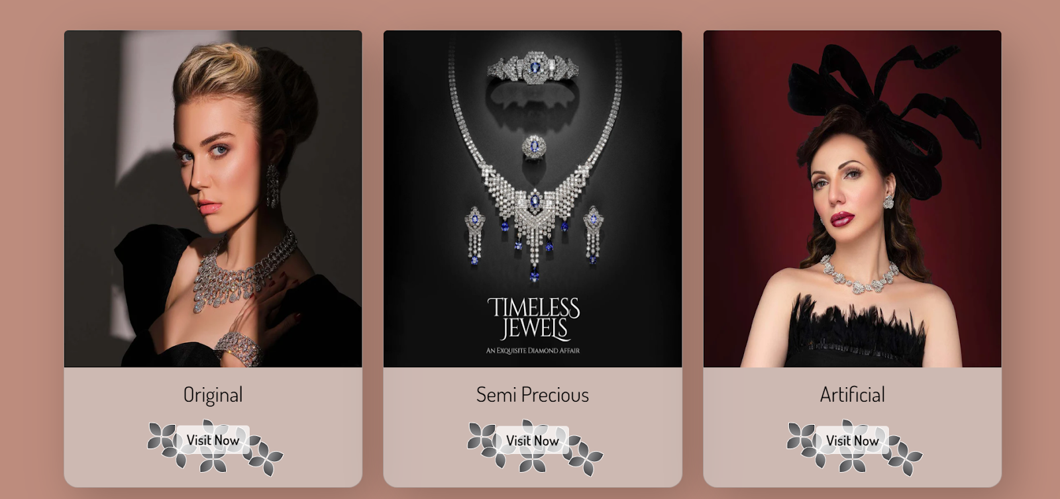

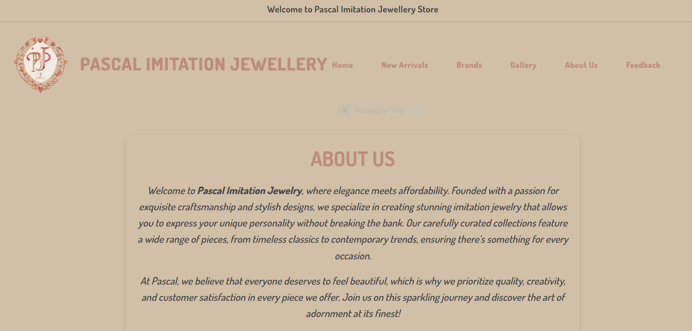

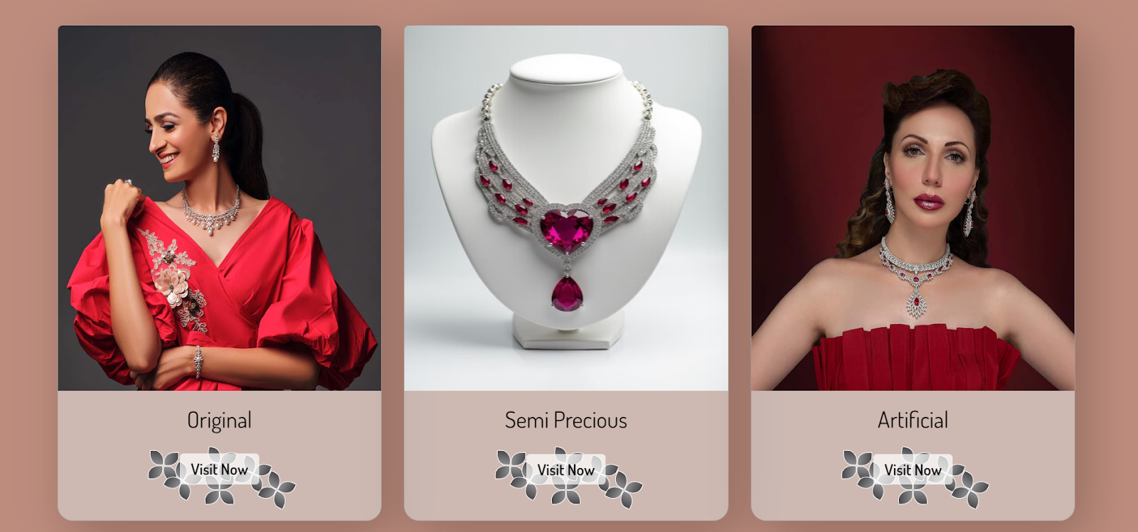

https://lh7-rt.googleusercontent.com/docsz/AD_4nXfzxiuURLZdiluadxIz9UaXuDzkYmQspHP6Gt1PlGGArZEbQAA5movaxmp6kcNPNJ_dpq8tUZvg2bamEJGJxDMoIX0-RmfvMTMXKFPVcApku_lz5R1jxMhvzQDdoOGf0fO7LUQhnqmlkKwlgpCKQ8jVwsBwGY7xPBE5LYzk?key=7U-A7CmsqMxvhMwl_pdPHLdAhttps://lh7-rt.googleusercontent.com/docsz/AD_4nXcSKPdmVDnOrv903UFywNdfgJkNZtkfHM2sBK9PiahK9Yto2hiJT_JjefmjRSX2qdwqlGJ6ruJKqJQAqeNGfH1MaOaAhQgy6PgbmGtgSm1LaDCI9yztAbrbf7g0JzGabhKvjRhkR2GvalQF9UUKWetwL8EVyGh32pwhu27IOA?key=7U-A7CmsqMxvhMwl_pdPHLdAhttps://lh7-rt.googleusercontent.com/docsz/AD_4nXc2k73HCmWsNEv6HbSUtpVnLx_MkcWgMZnCz5sTmO_7z60cQ5TjM4vXbUUDZf6GkMierWI-LzumMK7Wyvs22CJGIo9lGU9xQ7UhVnUsbLA6sloXCl4i0bjGzowXG4nCvCjouSdLICdS4rQuZH_-G0Fh2isqtUIc7ZvyJgRDqg?key=7U-A7CmsqMxvhMwl_pdPHLdAhttps://lh7-rt.googleusercontent.com/docsz/AD_4nXcrGJqolLQcLrTbC1a3hLihYDBzRYm4mnOv6s11MNq4I3T-5-oHzxZqgdd10V-g7KXmSdwS3vrmvXMy3NVlM0p79XLL9642YZy4uxHbQuEcizGZmm49ir-MpetZ0FCIHtaiEt9W7PLc4YMbQnpeXNx9uyOo99WpRCrIy5slyQ?key=7U-A7CmsqMxvhMwl_pdPHLdAhttps://lh7-rt.googleusercontent.com/docsz/AD_4nXenddCpE4YNAjORW8ij5fVYqt0sJu-QQfCbJGncs86Uxp2Higyyj_HbvlrBmU1BC_XiT2N1AGoOLO1o-YDJLgUBb6Fuqesw30Oom_USkBbkKgl4a_8XYjQ5XA8YVrIegz_nCE8XisoXc_613HI7Ul1lUYFvYxgKwvwGgOXE2Q?key=7U-A7CmsqMxvhMwl_pdPHLdAhttps://lh7-rt.googleusercontent.com/docsz/AD_4nXfTVDqKlG9GsYV-MujRYYGgTwkRIlpJ4y-WhpF0S-t8AYg82k9mYWT5OzBm-0aEl38dbiZjeN9JK3PGzVOzSwhv2BoQs2BTAEATLYu8tQfYYhY-dQ1Qon2uk_r8RybH82hS0LO4VtYK2PPcS9mBoMnLUdFTURB0RcIiWDZNfg?key=7U-A7CmsqMxvhMwl_pdPHLdAhttps://lh7-rt.googleusercontent.com/docsz/AD_4nXcUM79eijBqFatPbARL9GDzCH3VM5gvUAU0o2xXwuKwoqjESrPGEH3dftMry7MM1viIiOMx1WqQelKgtoBiuUXOJ3z6TmjMhFDdFRpKsc0f3o-817mhyIXtIF0uBLetsSJwxzuUGMrFAnegbucUcPKEM2cSlKoStbbTOqfL?key=7U-A7CmsqMxvhMwl_pdPHLdAhttps://lh7-rt.googleusercontent.com/docsz/AD_4nXftOYAT92BXO_UkVd08dTY-QENZRr78RHJ0WzVnGjLZ4Wis_fVJv6LRg7MeoZtHQBbL9pTI9BMA1ROXO73A79ME_8YPhYXIftvDvCpvTmwnIm6f58c-uJBCL_gIudxPpovYeOQAkMjtcMsV0CUcibI30zb6yX20BHPcxyohxg?key=7U-A7CmsqMxvhMwl_pdPHLdAhttps://lh7-rt.googleusercontent.com/docsz/AD_4nXff7f0powKQ0a96vyOe1ego9t21C2bpM3eXGiH6jt05izAtSkvEVxkDcwOiEI-hla_dYDBhZpLAEQ-AF6xYO9yZf5k_YmABmwIwwdCA10DBmX6--2xmbBW7CIuilBsJ4OA2mtwABk8RDu44bOIIKjQ-2w7zmOZVjPx5BdPtNQ?key=7U-A7CmsqMxvhMwl_pdPHLdA